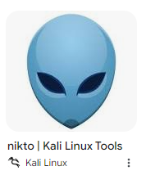
NIKTO Tool
Nikto is an open-source web server scanner used to identify vulnerabilities, outdated server software and security misconfigurations. Performs comprehensive testing and security issues. (Nikto-Licensing, n.d)
Test Case Type: | Performance Criteria Evaluation | Test Case Version: |  | Nikto_01
Test Environment: | Virtual Testing using Kali Operating System in VMWare Professional Machine | Test Input: | Target Website: 108.61.212.237  Scanme.nmap.org  Iplist.txt, iplist2.txt, nikto_result.csv
Tester Name: | Hope | Date of Testing: | 2/10/2024
Criteria Type | Tool Name: Nikto | Test Comments |  | Artifacts
Tool Type: | Open-Source Tool | This is license under GNU copyright |  | Fig 1
Version No: | Nikto 2.5.0 | Latest Version found in GitHub |  | Fig 1
Latest Update: | Dec 4, 2023 | Not Frequently updated |  | Fig 1
Cost Effective: | Free | Already installed in Kali |  | Fig 2
Integration: | High | Can implement with Burp Suite, Nmap |  | Fig 3
Ease of Use: | High | Requires understanding on commands syntax |  | Fig 4
Accuracy: | High | Identified web vulnerabilities but requiring manual validation of the findings. |  | Fig 5
Performance/Speed: | High | Started 13:24:00  Finished 13:28:13 |  | Fig 7
Usability: | Moderate | Easy to install, CLI operate only that may disadvantages to beginners.
Scalability: | Moderate | Not natively designed for commercial or large distributed system
Reporting: | High | Available in HTML, text as well |  | Fig 8
Steps use | Action | Actual Result |  | Artifacts
1.Setup | Install : Nikto Kali Terminal  Login: http://108.61.212.237/DVWA  Type: Nikto -h scanme.nmap.org | As Expected |  | Fig 3
2.Find Port scan | Type: nmap 108.61.212.237 -oG iplist.txt  Type: cat iplist.txt |grep “Ports: 80/open” | As Expected |  | Fig 4
3. Create script file | Type: nano iplist2.txt Write: 108.61.212.237, Press: Enter to save  Type: cat iplist2.txt | As Expected |  | Fig 5
4. Initial Target scan | Type: nikto -h iplist2.txt -o nikto_result.csv -Format CSV | Success |  | Fig 6
5. Analyse | Review if False Positive Result | Success rate with attempts in 253 seconds
Tool Strengths |  | Tool Weaknesses
- Open-Source tool  - Supports various output format  - Integrate with other tools, system and reporting platform  - Fast Set up run with Windows, Linux, MacOS  - Well Supported by the Community of users and Developers |  | - Prone to False Positives needs to manually verifies result  - Can be time consuming, and slow  - No Graphic User interface  - Outdated Findings might miss the latest vulnerabilities

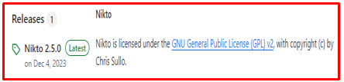
Figure 1 Nikto Updates & License
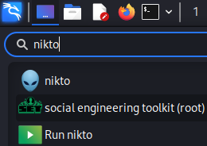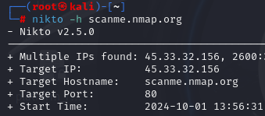
Figure 2 Search Nikto & Figure 3 Nikto scans with Nmap server
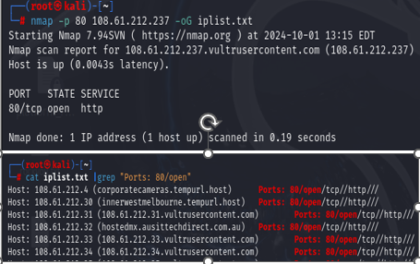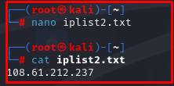
Figure 4 Port scan Result through Nmap & Figure 5 Create new file iplist2.txt
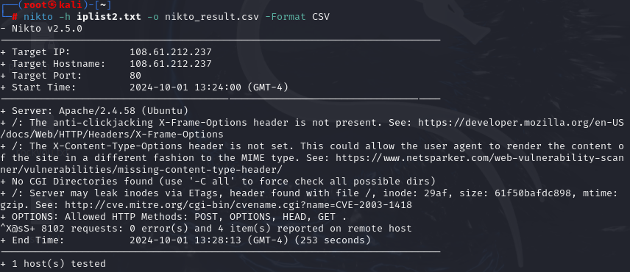
Figure 6 Nikto Scan Result
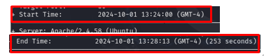
Figure 7 Scan Start & End Time
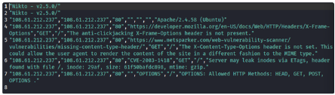
Figure 8 Report CSV Format

